Mender app

1. USER SIDE:- As we know, a normal user can change the type and can “become a mender” with same account.  
   So on the website we need to keep the same flow.

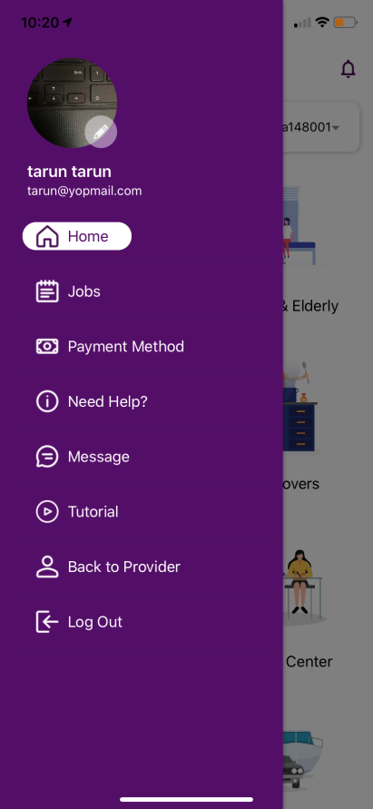

1. It’s website page we need to follow the app flow and don’t need to add the user/provider field extra



1. Provider can also change their type and can back to user.  
   We need to handle this feature for website as well.

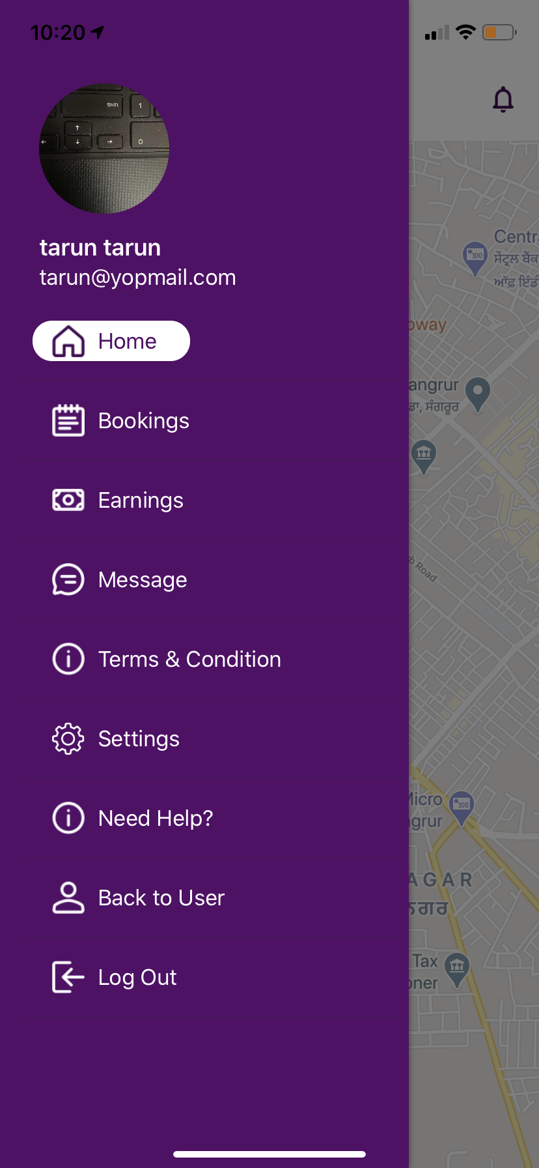

1. Provider can add the services from their account and can edit all the things   
   For any service need to add price field.

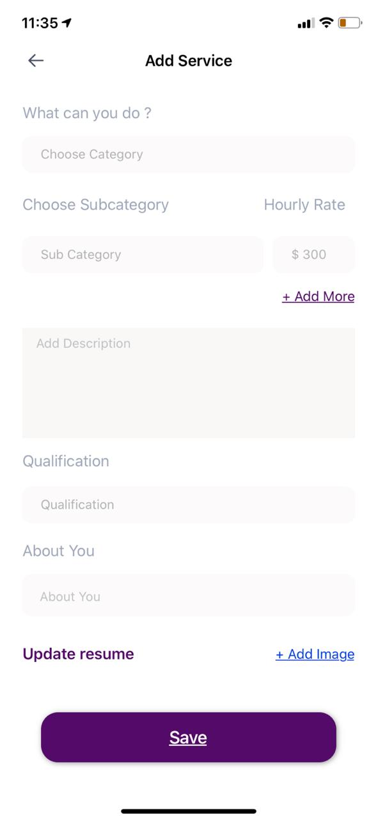

1. Earning for provider

